Squaring a Sorted Array (Two-Pointer)

1. Aim:
To write a C program that squares each element of a sorted array and displays the squared values in a sorted order using Two-pointers technique in O(N) time.
2. Pseudocode:
- Get input for N and sorted Array first
- Set left and right to two extremes of the arr and position of the result also.
- Loop till left <= right and compare left value and right value absolute ones
- Place the largest square at result[position].
- Move the pointers that supplied the largest value and decrement current position
- Print the result array.
3. C program:
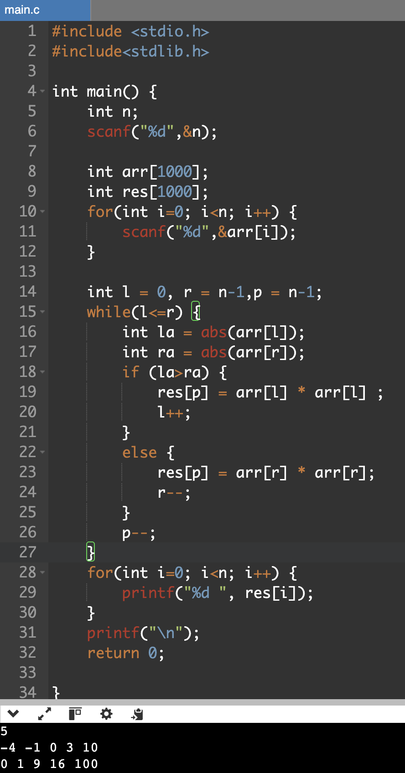
4. Result:
Thus ,the sorted squared array was produced successfully using the two pointers technique
Cumulative Resource Consumption (Prefix Sum)

1. Aim:
To write a C program that computes the prefix sum array for a given list of hourly packet transmissions.

2.pseudocode
1. Get input N and the array arr.
2. Set runningsum = 0
3. For each arr[i] ,add it to the running sum.
4. Store running sum as the prefix sum at index i.
5. Print all prefix sum values.

3.C program:

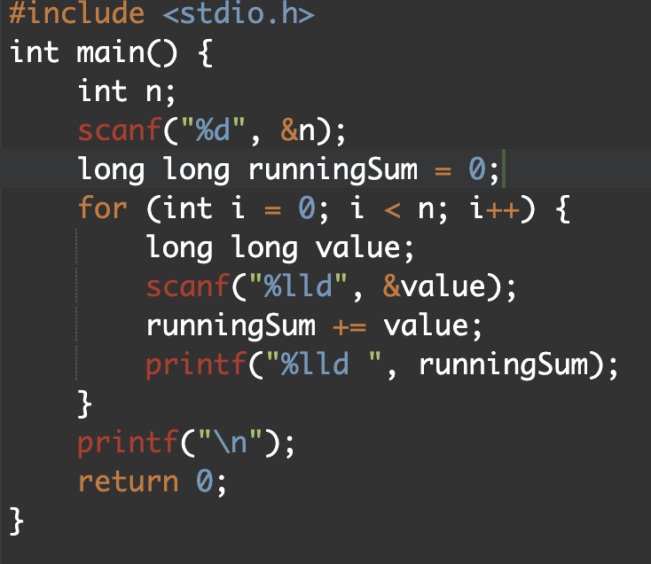

4.Output:
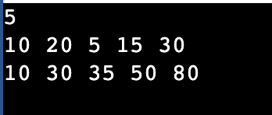

5. Result:
Thus, the cumulative running sum was calculated successfully using prefix sums.
Grouping Active Sectors (Fixed-Size Sliding Window)

1.Aim:
To write a C program that finds the minimum number of swaps needed to group all 1s together in a binary array using a fixed size sliding window.

2.Pseudocode:
1. Input the binary array of size N.
2. Calculate 'onesCount', the total number of 1s in the array.
3. If 'onesCount' is 0 or 1, the result is 0.
4. Identify the first window of size 'onesCount' and count the number of 1s it contains.
5. Slide this window across the array, tracking the maximum number of 1s found in any position ('maxOnes').
6. The minimum swaps required is 'onesCount - maxOnes'.

3.C program
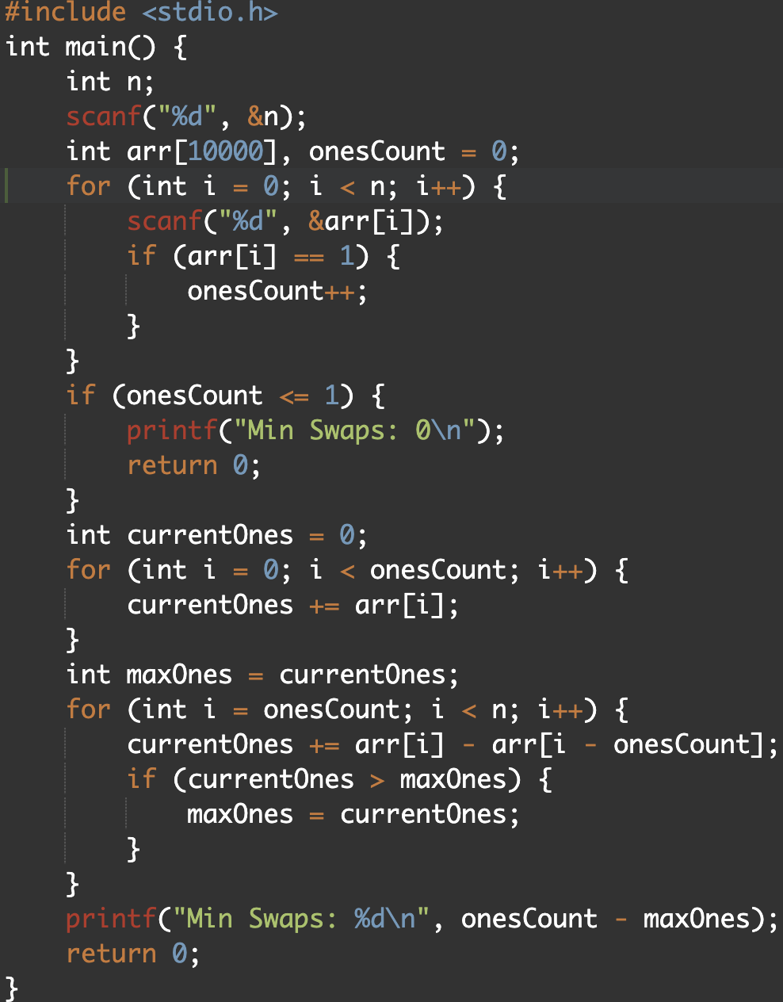

4. Output:
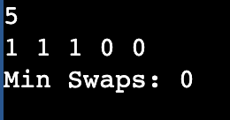
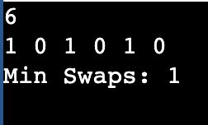

5. Result:
Hence, the peak count of sequential tasks feasible within the defined power threshold has been determined.
Maximum Task Window Within Budget (Variable-Size Sliding Window)

1.Aim:
To write a C program that finds the maximum length of a contiguous task sequence whose total energy cost does not exceed the given budget.

2.Pseudocode:
1. Read N, P, and the energy cost array.
2. Initialize start = 0, currentSum = 0, and maxLength = 0.
3. For each end index, add arr[end] to currentSum.
4. While currentSum > P, subtract arr[start] and increment start.
5. Update maxLength with the current valid window size.
6. Print maxLength

3.C Program:

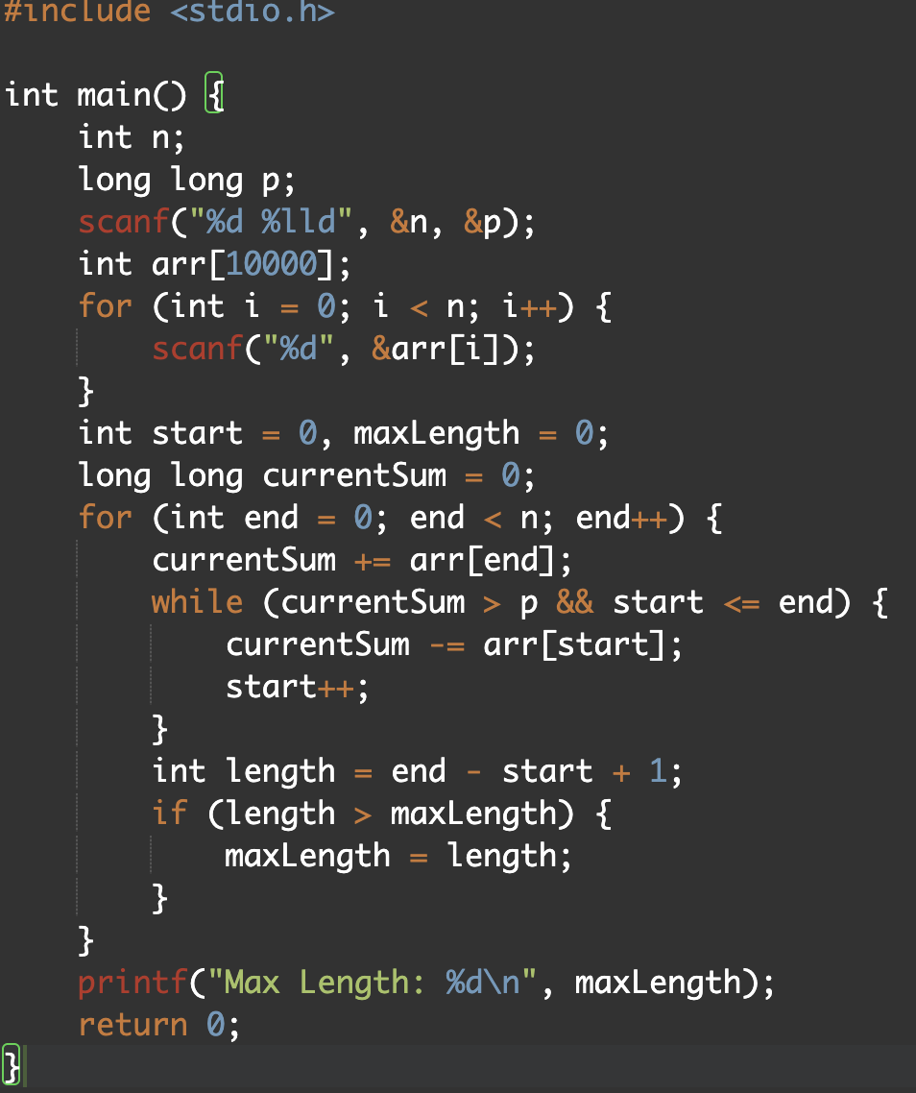

4.Output:
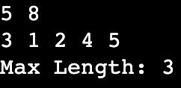

5.Result:
The program successfully identified the greatest count of sequential activities permissible under the defined power constraints.

Sliding Window Maximum Peak (Monotonic Window Queue)

1.Aim:
To write a C program that prints the maximum value in every sliding window of size K using a monotonic queue.

2.PseudoCode:
1. Read N, K, and the array arr.
2. Create an array-based deque to store indices.
3. For each index i, remove smaller or equal values from the back of the deque.
4. Insert it at the back of the deque.
5. Remove indices from the front if they fall outside the current window.
6. Once the first window is formed, print arr[deque front] as the window maximum.

3.C Program:
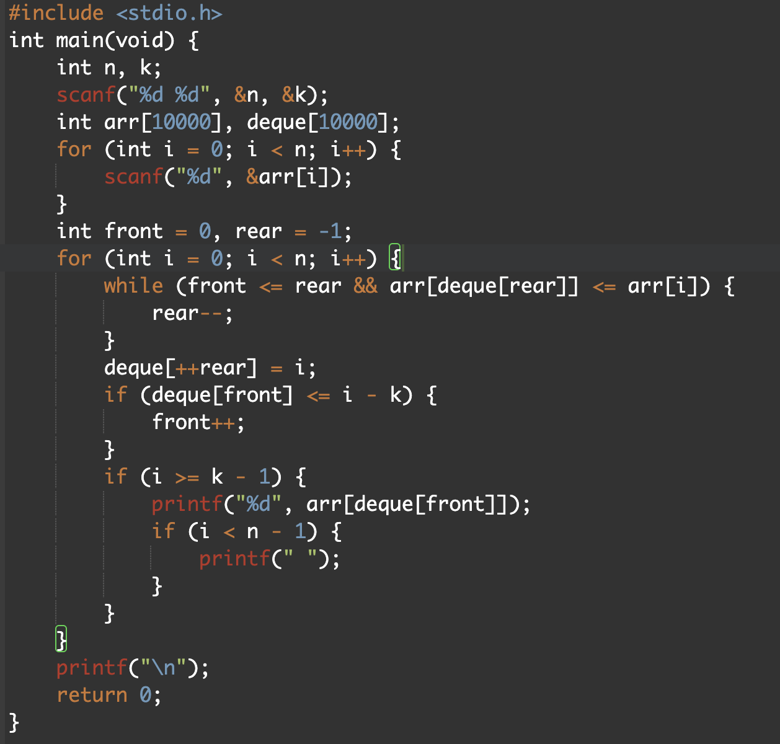

4.output:
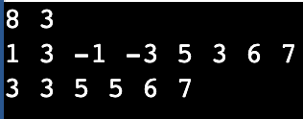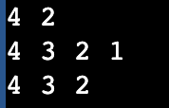

5.result:
Thus, the maximum value for every sliding window was printed successfully using a monotonic queue.

